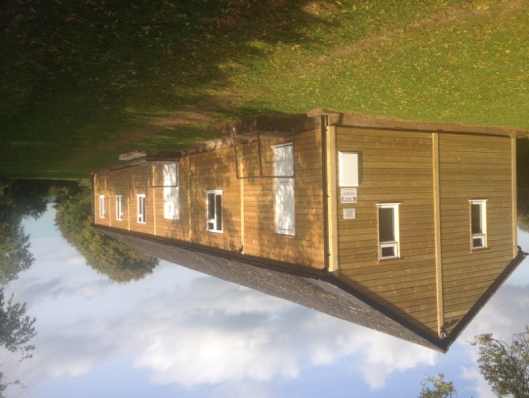
Tiverton and District Scout HQ at Halberton Booking Form.
Tiverton and District Scout HQ Greenway Halberton Tiverton Devon EX16 7AE
Warden: Nick Dawe 8 Post Hill Tiverton EX16 4ND
Tel – 01884 254953/07504325240 backup contact number 07925351558
Email :- nick.dawe@hotmail.co.uk
Please complete this form and email to Nick Dawe to confirm your booking.
Name of Leader in Charge.
Group and Section name.
Phone Contact details of leader in charge.
Email address
Name and Email address of treasurer to whom the invoice will be sent
Date of arrival and approximate time.

Date and approximate time of departure.

Reminder of charges. Daytime £20 (8am – 11pm), Evening £15 (6pm – 11pm), Overnight additional £20,
Outside Organisations and Private Hire:- £30.00 per day, £30.00 overnight, £25.00 evenings.
Winter additional electricity charge in months of November to end of March.
By completing this form you are agreeing to the following terms:
- Remove all rubbish and waste including outdoor area. There is no council waste removal.
- Leave kitchen clean and check taps are turned off.
- Check all electricity is switched off, apart from small heaters in toilets which need to be left at a low setting during the winter.
- Check toilets are flushed and clean.
- Leave floors is a reasonable condition.
Please contact the warden if you have encountered any problems with this hire. We hope you will enjoy your stay.

